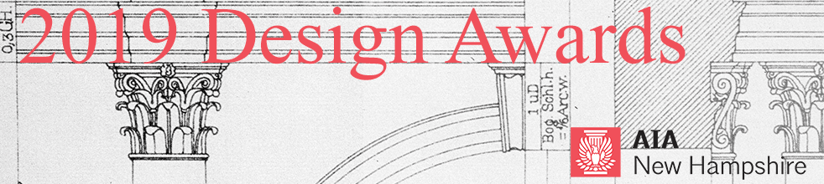
CALL FOR ENTRIES – 2019 Excellence in Architecture 25 Year Design Award

In honor of the 25th Anniversary of the AIANH Awards Program in 2009, AIANH instituted a special 25-year Award. This award recognizes architectural design of enduring significance on a project that has stood the test of time for 25 to 35 years. The project must have been designed by an architect licensed in the state of New Hampshire at the time of the project’s completion. Projects must have been completed between 1984 and 1994 and have contributed meaningfully to the New Hampshire built environment. Individuals may submit projects of their own design or designed by others.

SUBMISSION SUPPORT
All submissions will be received via Submittable, an online portal: https://aianewhampshire.submittable.com/submit
It is recommended to use Chrome or Firefox browsers for submissions made through Submittable.
If you encounter technical difficulty with your awards submission, please contact: Submittable Tech Support at: (855) 467-8264, ext. 2 or support@submittable.com. Non-technical questions about awards can be addressed to: Bonnie Kastel, bkastel@aianh.org.

SUBMISSION DEADLINE
February 22, 2019, 5 PM
All submissions must be complete by this date. Prior to submission, drafts may be saved to your Submittable account and modifications made.
You may submit multiple projects to this awards program. Each project must be submitted separately.

NOTIFICATION OF AWARDS
Submitters will be notified after March 8 and awards will be conferred on Thursday, March 28, 2019 at the AIA New Hampshire Awards Banquet at the Currier Museum of Art in Manchester, NH. Registration for the Awards Banquet will open in February.

ELIGIBILITY
- Anyone may nominate a project for the 25-Year Award.
- The award is open to architectural projects of all classifications and may be one building or a related group of buildings forming a single project.
- The project must be located in New Hampshire, must have been completed between 1984 and 1994, and must have been designed by an architect licensed in New Hampshire at the time of the project’s completion.
- The project must be standing in a substantially completed form and in good condition.
- The project should still carry out the original program. Change of use is permitted when it has not basically altered original intent.
- The project must have excellence in function—in the distinguished execution of its original program and in the creative aspects of its statement by today’s standards. Building and site together should be examined. Any alteration to the immediate context shall be taken into consideration.

CRITERIA
Entries will be judged on their own merit regardless of project size or type. Primary criteria are overall design excellence including aesthetics, clarity, creativity and appropriate functionality. Submissions should clearly address these areas. The jurors’ decision will be based solely on the materials submitted.

FEES
There are no entry fees for the 25 Year Award.

SUBMISSION REQUIREMENTS
All submissions for the 2019 AIA New Hampshire Design Awards must be digital and submitted by Friday, February 22, 2019, 5 PM. No binders will be accepted. The decisions of the jurors will be based solely on the materials submitted.
Project Information (as possible)
- Project Name
- Project Location
- Original Completion Date
- Name of Original Architect
- Statement by person making nomination (500 words or less) describing reasons for submission.
- Statement of the condition of the project (500 words or less) in regard to use and general appearance at the time of the submission, along with a brief outline of the transformations, if any, that may have taken place since first built.
- Photo credits
- Presentation Board: This board is used for publicity purposes. It will be on display at the Awards Banquet in March. Thereafter, it will be on exhibit at various locations around New Hampshire. This year we plan to use a layout template to standardize the overall board design. This project is nearly complete. Information about the presentation boards will be available shortly on Submittable.
- Submitters must agree to the 2019 AIA NH Permission Form for Textual and Visual Works provided on the online submission form.
Digital Slides
Please note: Submissions will be reviewed by jurors on a computer and/or projection screen. Slides should be legible when printed at 8.5”x11”.
- Submissions must include no more than twelve (12) digital slides arranged in the order you wish them viewed. Start each file name with its order number (ie. 1_front facade.jpg, 2_rear elevation.jpg).
- Images should describe the project in its original condition as well as describe changes made, if any, in intervening years.
- Each digital slide must be 2MB or less, in jpg format.
- A composition of drawings, images, and other illustrations may constitute one (1) digital slide.
- Do not include project narrative in the digital slide section.

JURORS
The jury for the 2019 AIANH Design Awards will be composed of professional colleagues from the state of Rhode Island.

FREQUENTLY ASKED QUESTIONS:
Do I have to start and finish my submission in one session?
No. You can start your submission and return to finish it before the deadline date. To do so, scroll to bottom of submission page and click “Save Draft” button.
Can I make multiple entries?
Yes. However, you must submit your first entry before starting on a new entry.
What if I want to make changes to my entry after I have completed my submission?
Once you click “Submit” you will need to contact bkastel@aianh.org to make edits.
ADDITIONAL QUESTIONS
Additional questions should be directed to Bonnie Kastel, AIA New Hampshire Executive Director, at bkastel@aianh.org or 603.501.1881.

