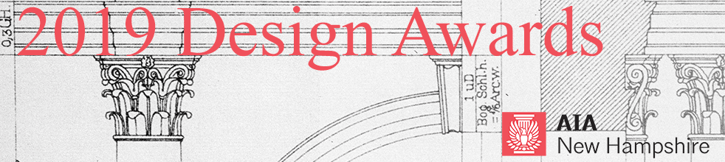
CALL FOR ENTRIES – 2019 Excellence in Architecture Design Awards

AIA New Hampshire is committed to excellence in architecture and looks forward to celebrating outstanding works of architecture through its annual Design Awards Program. The purpose of the program is to recognize achievements in design by New Hampshire architects and to honor the project teams and the clients who work with them to create and enhance our built environment. Projects should exemplify the value of good design in creating livable communities and safe, valuable, and sustainable buildings, neighborhoods, towns, and cities.

SUBMISSION SUPPORT
All submissions will be received via Submittable, an online portal: https://aianewhampshire.submittable.com/submit
It is recommended to use Chrome or Firefox browsers for submissions made through Submittable.
If you encounter technical difficulty with your awards submission, please contact: Submittable Tech Support at: (855) 467-8264, ext. 2 or support@submittable.com. Non-technical questions about awards can be addressed to: Bonnie Kastel, bkastel@aianh.org.

SUBMISSION DEADLINE
February 22, 2019, 5 PM
All submissions must be complete by this date. Your submission will be received by AIANH after payment has been made. If your submission fee has not been paid, AIANH will not see or have any record of your submission. Payment is the last step of the submission process. Once your submission fee is paid, your submission cannot be edited. Prior to that point, drafts may be saved to your Submittable account and modifications made.
You may submit multiple projects to this awards program. Each project must be submitted and paid for separately. If you submit multiple projects, remember to select the discounted, subsequent entry fee after the first entry.

NOTIFICATION OF AWARDS
Submitters will be notified after March 8 and awards will be conferred on Thursday, March 28, 2019 at the AIA New Hampshire Awards Banquet at the Currier Museum of Art in Manchester, NH. Registration for the Awards Banquet will open in February.

ELIGIBILITY
- This award recognizes and honors excellence in architectural design by registered, licensed architects who are members of AIANH.
- Firms domiciled in NH may submit projects anywhere in the world.
- Firms domiciled outside NH may only submit projects located in NH. One principal from this firm must be a member of AIANH. If you are not currently a member, complete the AIANH Component Allied Membership form and send it with payment to the AIANH office: bkastel@aianh.org.
- Built projects substantially completed after January 1, 2009 are eligible.
- Each entrant may submit any number of eligible entries with the appropriate fees for each entry.
- Projects that have been honored in a past AIANH Design Awards program are not eligible (unless the project was submitted in the Unbuilt category and the project has since been built).
- Projects previously submitted that have not won an award may be entered again but may not be submitted more than two years consecutively.
- The submitted work must be eligible for publicity and reproduction.

CRITERIA
Entries will be judged on their own merit regardless of project size or type. Primary criteria are overall design excellence including aesthetics, clarity, creativity and appropriate functionality. Submissions should clearly address these areas. The jury may elect to honor projects by building type or other category or may choose to make no such distinctions. The jurors’ decisions will be based solely on the materials submitted.

FEES
First project entry: $220 ($160 + $60 for presentation board production)
Additional project entries: $185 ($125 + $60 for presentation board production)
Each project submission requires a presentation board that will be used for display during the Awards Banquet and, thereafter, on tour throughout New Hampshire during 2019.
All fees are not refundable and must be paid online via credit card at time of submission. Submissions cannot be received and marked complete until payment is made.

SUBMISSION REQUIREMENTS
All submissions for the 2019 AIA New Hampshire Design Awards must be digital and submitted by Friday, February 22, 2019, 5 PM. No binders will be accepted. The decisions of the jurors will be based solely on the materials submitted.
Project Information (as possible)
- Project Name
- Project Category
- Project Location
- Completion Date
- Architecture or A/E Firm Name
- Architect of Record
- Design Architect
- Project Team
- General Contractor
- Project Consultants
- Client
- Client Permission
- Project narrative: A brief, 400 word or less, description of the project.
- Do not include any identification of entrant or project team in the project narrative section.
- The jurors have a limited time with each submission. Please format text accordingly.
- Photo credits
- Presentation Board: This board is used for publicity purposes. It will be on display at the Awards Banquet in March. Thereafter, it will be on exhibit at various locations around New Hampshire. This year we plan to use a layout template to standardize the overall board design. This project is nearly complete. Information about the presentation boards will be available shortly on Submittable.
- Publicity Description: A brief, 150 word or less, description of the project that will be used for promotional purposes. Unlike the Project Narrative, you may include identifying information about your firm, project and client.
- Submitters must agree to the 2019 AIA NH Permission Form for Textual and Visual Works provided on the online submission form.
Digital Slides
Please note: Submissions will be reviewed by jurors on a computer and/or projection screen. Slides should be legible when printed at 8.5”x11”.
- Submissions must include no more than twelve (12) digital slides arranged in the order you wish them viewed. Start each file name with its order number (ie. 1_front facade.jpg, 2_rear elevation.jpg).
- Each digital slide must be 2MB or less, in jpg format.
- A composition of drawings, images, and other illustrations may constitute one (1) digital slide.
- Do not include any identification of entrant or project team in the digital slide section.
- Do not include project narrative in the digital slide section.
- Submitters may be asked to provide high-resolution imagery for publication after judging is complete.

JURORS
The jury for the 2019 AIANH Design Awards will be composed of professional colleagues from the state of Rhode Island.

FREQUENTLY ASKED QUESTIONS:
Do I have to start and finish my submission in one session?
No. You can start your submission and return to finish it before the deadline date. To do so, scroll to bottom of submission page and click “Save Draft” button.
Can I make multiple entries?
Yes. However, you must submit your first entry before starting on a new entry.
What if I want to make changes to my entry after I have completed my submission?
Once you click “Submit” you will need to contact bkastel@aianh.org to make edits.
ADDITIONAL QUESTIONS
Additional questions should be directed to Bonnie Kastel, AIA New Hampshire Executive Director, at bkastel@aianh.org or 603.501.1881.

