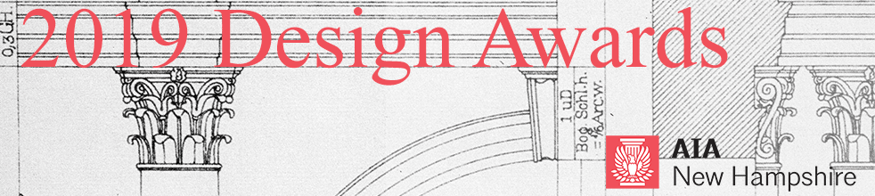
CALL FOR ENTRIES – 2019 Unbuilt Architecture Design Awards

AIA New Hampshire is committed to excellence in architecture and looks forward to celebrating outstanding works of architecture through its annual Design Awards Program. The purpose of the program is to recognize achievements in design by New Hampshire architects and to honor the project teams and the clients who work with them to create and enhance our built environment. Projects should exemplify the value of good design in creating livable communities and safe, valuable, and sustainable buildings, neighborhoods, towns, and cities.
This award recognizes unbuilt architectural designs of any project type, including purely theoretical projects.

SUBMISSION SUPPORT
All submissions will be received via Submittable, an online portal: https://aianewhampshire.submittable.com/submit
It is recommended to use Chrome or Firefox browsers for submissions made through Submittable.
If you encounter technical difficulty with your awards submission, please contact: Submittable Tech Support at: (855) 467-8264, ext. 2 or support@submittable.com. Non-technical questions about awards can be addressed to: Bonnie Kastel, bkastel@aianh.org.

SUBMISSION DEADLINE
February 22, 2019, 5 PM
All submissions must be complete by this date. Your submission will be received by AIANH after payment has been made. If your submission fee has not been paid, AIANH will not see or have any record of your submission. Payment is the last step of the submission process. Once your submission fee is paid, your submission cannot be edited. Prior to that point, drafts may be saved to your Submittable account and modifications made.
You may submit multiple projects to this awards program. Each project must be submitted and paid for separately. If you submit multiple projects, remember to select the discounted, subsequent entry fee after the first entry.

NOTIFICATION OF AWARDS
Submitters will be notified after March 8 and awards will be conferred on Thursday, March 28, 2019 at the AIA New Hampshire Awards Banquet at the Currier Museum of Art in Manchester, NH. Registration for the Awards Banquet will open in February.

ELIGIBILITY
- Architects who submit must be members of AIA New Hampshire.
- Firms domiciled outside NH may only submit projects located in NH. One principal from the firm must be a member of AIANH If you are not currently a member, complete the AIANH Component Allied Membership form and send it with payment to the AIANH office: bkastel@aianh.org.
- Emerging professionals do not need to be members but must be working in a New Hampshire firm.
- Students do not need to be members but must be either from New Hampshire or attending school in New Hampshire.
- Unbuilt architectural designs of any project type are eligible including purely theoretical projects and unbuilt, client-sponsored projects (buildings, interiors, transportation infrastructure, monuments, etc. – all project types). Projects under construction or otherwise apparently assured of construction are not eligible.
- There are no restrictions on the presumed or imagined location of projects. The intent is to invite unbuilt work by practicing design professionals, design educators, and design students.

CRITERIA
The jurors’ decisions will be based on the materials submitted. The jury may create award tiers and categories as it deems appropriate.

FEES
AIANH Architect First project entry: $140 ($80 + $60 for presentation board production)
AIANH Architect Additional project entries: $100 ($40 + $60 for presentation board production)
Emerging Professionals and Students First project entry: $25
Emerging Professionals and Students Additional project entries: $70 ($10 + $60 for presentation board production)
The fee for presentation board production is waved for Emerging Professional and Student First Project entry. Additional entries require payment of presentation board production.
All project submissions require a presentation board that will be used for display during the Awards Banquet and, thereafter, on tour throughout New Hampshire during 2019.
All fees are not refundable and must be paid online via credit card at time of submission. Submissions cannot be received and marked complete until payment is made.

SUBMISSION REQUIREMENTS
All submissions for the 2019 AIA New Hampshire Design Awards must be digital and submitted by Friday, February 22, 2019, 5 PM. No binders will be accepted. The decisions of the jurors will be based solely on the materials submitted.
Project Information (as possible)
- Project Name
- Architecture or A/E Firm Name
- Architect of Record
- Design Architect
- Project Team
- Project narrative: A brief, 150 word or less, description of the project.
- Do not include any identification of entrant or project team in the project narrative section.
- The jurors have a limited time with each submission. Please format text accordingly.
- Photo credits
- Presentation Board: This board is used for publicity purposes. It will be on display at the Awards Banquet in March. Thereafter, it will be on exhibit at various locations around New Hampshire. This year we plan to use a layout template to standardize the overall board design. This project is nearly complete. Information about the presentation boards will be available shortly on Submittable.
- Submitters must agree to the 2019 AIA NH Permission Form for Textual and Visual Works provided on the online submission form.
Digital Slides
Please note: Submissions will be reviewed by jurors on a computer and/or projection screen. Slides should be legible when printed at 8.5”x11”
- Submissions must include no more than ten (10) digital slides arranged in the order you wish them viewed. Start each file name with its order number (ie. 1_front facade.jpg, 2_rear elevation.jpg).
- Each digital slide must be 2MB or less, in jpg format.
- A composition of drawings, images, and other illustrations may constitute one (1) digital slide.
- Do not include any identification of entrant or project team in the digital slide section.
- Do not include project narrative in the digital slide section.
- Submitters may be asked to provide high-resolution imagery for publication after judging is complete

JURORS
The jury for the 2019 AIANH Design Awards will be composed of professional colleagues from the state of Rhode Island.

FREQUENTLY ASKED QUESTIONS:
Do I have to start and finish my submission in one session?
No. You can start your submission and return to finish it before the deadline date. To do so, scroll to bottom of submission page and click “Save Draft” button.
Can I make multiple entries?
Yes. However, you must submit your first entry before starting on a new entry.
What if I want to make changes to my entry after I have completed my submission?
Once you click “Submit” you will need to contact bkastel@aianh.org to make edits.
ADDITIONAL QUESTIONS
Additional questions should be directed to Bonnie Kastel, AIA New Hampshire Executive Director, at bkastel@aianh.org or 603.501.1881.

